**LAB 4 TASK**

**Q1) Give the introduction of Windows 10 also difference between Windows 10 and Windows 7**

**Windows 10** is a personal computer operating system developed and released by Microsoft as part of the Windows NT family of operating systems. It was first released on July 29, 2015. Unlike previous versions of Windows, Microsoft has branded Windows 10 as a "service" that receives ongoing "feature updates". Devices in enterprise environments can receive these updates at a slower pace, or use long-term support milestones that only receive critical updates, such as security patches, over their ten-year lifespan of extended support. Windows 10's touch-oriented user interface mode was panned for containing regressions upon the touch-oriented interface of Windows 8. Critics also praised the improvements to Windows 10's bundled software over Windows 8.1, Xbox Live integration, as well as the functionality and capabilities of Cortana personal assistant and the replacement of Internet Explorer with Microsoft Edge.

**COMPARING THE WINDOW 10 with Windows 7**

|  |  |  |
| --- | --- | --- |
| **FEATURES NAMES** | **WINDOW 7** | **WINDOWS 10** |
| **Start Menu** | Start Menu that allows the user to see the applications and provides a search far to search for files and applications on the computer. | Gives a combinations of the Smart Menu on Windows 7 and also incorporates Live Tiles |
| **Assistance** | Windows Help that troubleshoots common problems | Makes search better and incorporates Voice Activated Personal Assistant – Cortana |
| **Convergence** | No convergence, or rather manual convergence. Windows 7 runs only on PCs and laptops, not on phones or tablets. | Seamless convergence on all devices. The same Windows 10 will run on the phone, tablet, laptop and even PCs |
| **Search** | Users can type in the search bar in the Start menu or in the Windows explorer to search within the system | Cortana is integrated into the Search feature, where instead of typing users can talk and ask Cortana to search something or open applications |
| **File Explorer** | Has Favorite which allow you to easily and quickly access frequently visited folders | Quick Access replaces Favorites. Allows users to access recent files and frequently visited folders |
| **Built in browser** | Internet Explorer 8 | New and improved Microsoft Edge that comes incorporated with Cortana and has a reading mode |
| **Security** | Only option is to set passwords. | Allows users to integrate biometrics tools such as fingerprint and retina scanners. |
| **Xbox** | No direct connection to Xbox | Comes with built-in Xbox app, offering a unified view of your games, the activity of friends, and gaming activities. Connected to Xbox Live and allows console connection to the game. |
| **Multiple Desktops** | No multiple desktops | Allows multiple desktops to separate applications and for a faster use within a single monitor so that users can access two applications on the same screen |
| **Multiple Applications** | Multiple applications in the traditional case, where the user can switch between the multiple running apps. | The SnapAssist feature allows users to run multiple apps next to each other. A new Snap Assist feature means up to four apps can be snapped per screen. |
| **Task View** | No task view. Closest is Alt+Tab, which opens a floating bar to show open windows. | Task View is now a button the lower bar of the screen which opens up all the open applications in a stack, allowing easier access to pick |
| **Update Method** | Windows Update | Windows Update, Windows Store, Windows Server Update Services |
| **Required Graphics Card** | DirectX 9 graphics processor with WDDM driver model 1.0  (Not absolutely necessary; only required for Aero) | DirectX 9 graphics device  WDDM 1.0 or higher driver |
| **Price** | About $80 at the time of Windows 10 launch | Is Free for all users that are using Windows 7 and Windows 8 for the first year after its launch |

**Q2) How software programs can be add or remove using control panel in windows 7?**

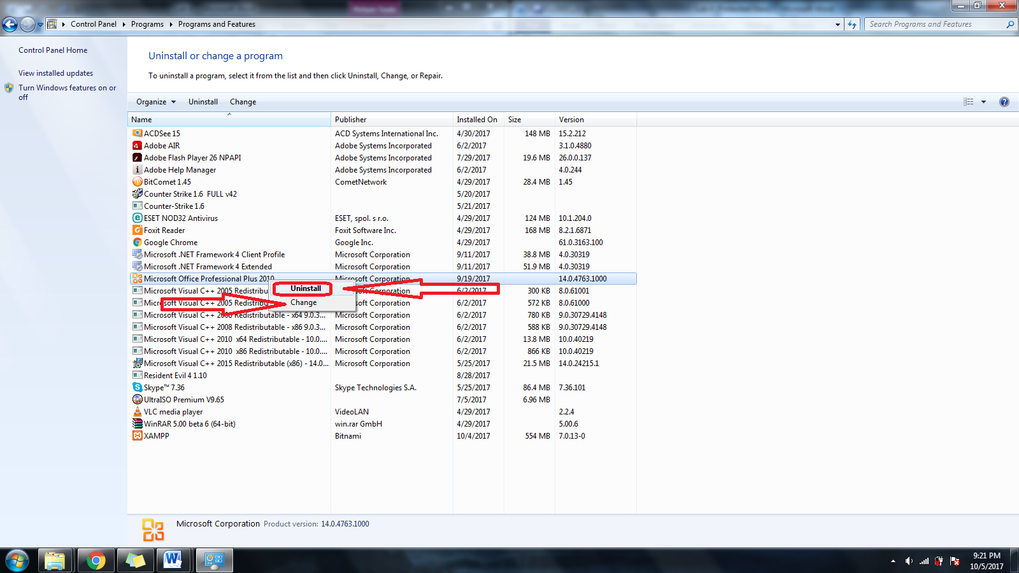

**Q3) Run all Programs and plot their performance.**

